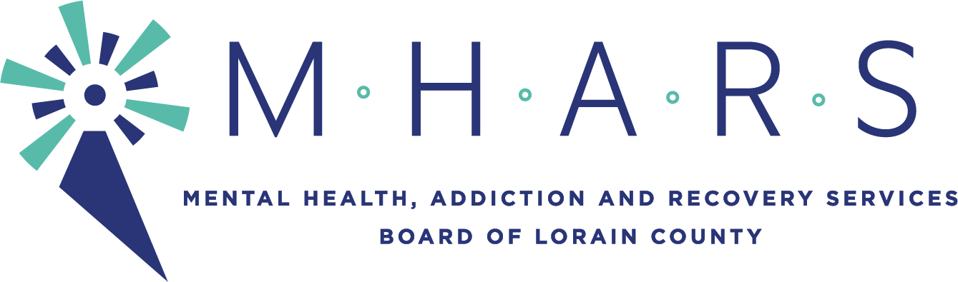

PUBLIC NOTICE

TO: Lorain County Residents and Community Partners

FROM: Barry Habony, Business Operations Director

SUBJECT: Finance Committee Meeting

DATE: Thursday, February 11, 2021

CC: See distribution list below.
______________________________________________________________________________

There will be a Finance Committee meeting on:

DATE: Tuesday, February 16, 2021
TIME: 5:00 p.m.
PLACE: The meeting will be seen by the public via Facebook Live.

Informational Items:
1. List of Contracts Authorized by the Executive Director on Behalf of the MHARS
Board of Directors (pg. 2)
2. Draft 5-Year Budget Forecast (forthcoming)
Recommendations:
1. Review and recommendation for approval of the MHARS Board FY21 Financial
Statements through January 2021. (pg. 3-11)
2. Review and recommendation for approval of the MHARS Board Listing of Expenses
for January totaling $1,579,310.28. (pg. 12-15)
3. Review and recommendation for approval of the MHARS Board FY21 budget
revisions. (pg. 16)
4. Review and recommendation for approval of Contract to be Authorized by the
MHARS Board of Directors. (pg. 18)
Discussion of any other finance related items.
Discussion of Consent Agenda items.
Next meeting of the Finance Committee will be March 16th 2021 at 5:00pm.

Distribution:
Lorain County Commissioners
Legislators
Local Mayors
Director, Ohio Department of Mental Health and Addiction Services
The Chronicle-Telegram
The Morning Journal
The Plain Dealer
MHARS Network of Lorain County
WEOL
WOBL/WDLW
WNZN

