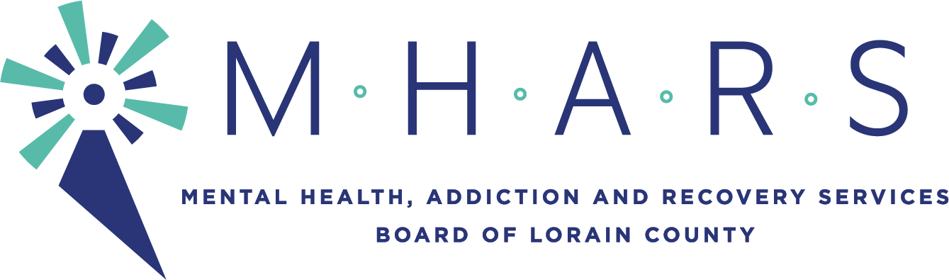

PUBLIC NOTICE

TO: All Board Members

FROM: Mark Johnson, Community Services Director

SUBJECT: Community Planning & Oversight Committee Meeting Notice

DATE: Friday, February 12, 2021

______________________________________________________________________________

There will be a CP&O Committee meeting on:

DATE: Wednesday, February 17, 2021

TIME: 5:15 p.m.

PLACE: The meeting will be seen by the public via Facebook Live.
AGENDA
I. Informational:
A. Crisis Continuum Update –The Nord Center Attachment A
B. Provider Presentation – Stella Maris – Attachment B
C. 120 Day Notice – Attachment C
D. Consultant – Crisis Continuum Project Management Position - Attachment D
II. Recommendations:
A. K-12 Initiatives Attachments E, F, G, H
B. State Opioid Response 2.0 Adjustments – Attachment I
I. Old Business
II. New Business
Following Meeting: March 17, 2021 5:15pm

