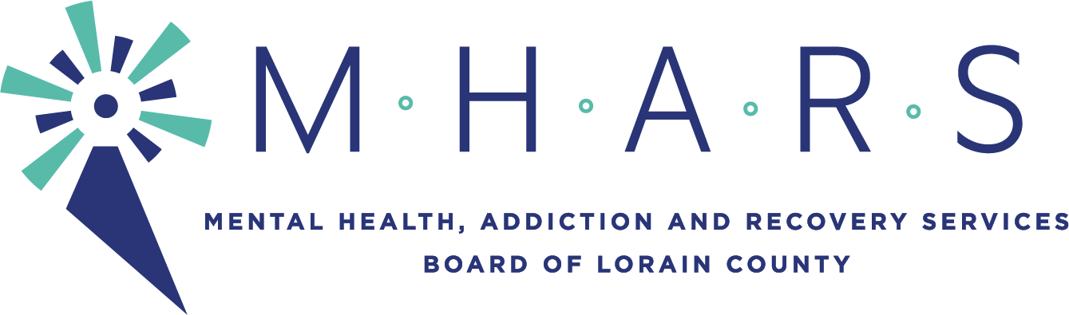

PUBLIC NOTICE

TO: Lorain County Residents and Community Partners

FROM: Barry Habony, Business Operations Director

SUBJECT: Finance Committee Meeting

DATE: Friday, March 19, 2021
______________________________________________________________________________

There will be a Finance Committee meeting on:

DATE: Wednesday, March 24, 2021
TIME: 5:00 p.m.
PLACE: The meeting will be seen by the public via Facebook Live

a. Informational Items:
1. List of Contracts Authorized by the Executive Director on Behalf of the MHARS
Board of Directors (pg. 2)
2. Current Preliminary 5-Year Budget Forecast (Narrative pg. 3-4 Spreadsheet
Forthcoming)

b. Recommendations:
1. Review and recommendation for approval of the MHARS Board FY21 Financial
Statements through February 2021. (pg. 5-13)
2. Review and recommendation for approval of the MHARS Board Listing of Expenses
for February totaling $1,102,846.66. (pg. 14-17)
3. Review and recommendation for approval of the MHARS Board FY21 budget
revisions. (pg. 18)
4. Review and recommendation for approval of Contract to be Authorized by the
MHARS Board of Directors. (pg. 20)

c. Discussion of any other finance related items

d. Discussion of Consent Agenda items

Next meeting of the Finance Committee will be April 13, 2021 at 5:00pm.

