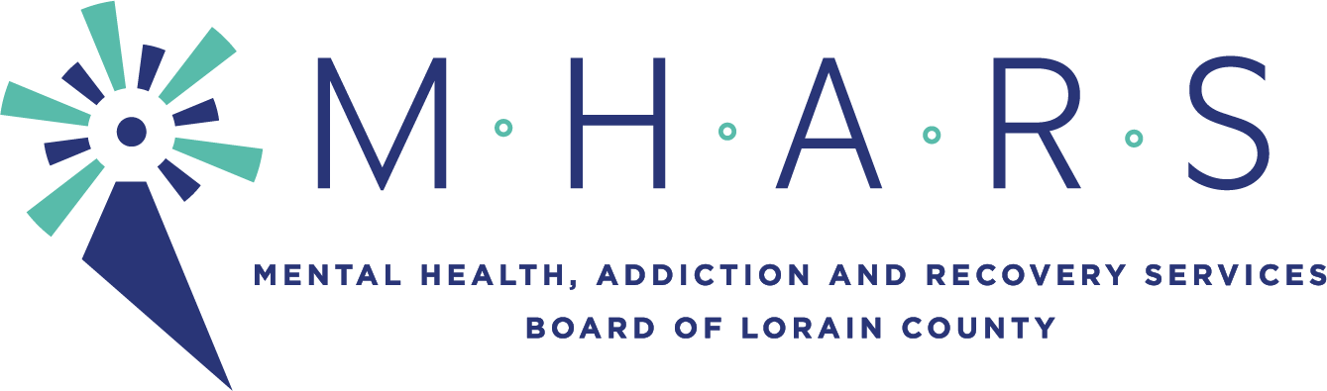
MHARS Ad Hoc Disparities Committee
Time: Apr 8, 2021 06:00 PM Eastern Time (US and Canada)

The meeting will be seen by the public via Facebook Live:
Facebook.com/mharslc

Committee members: Regan Phillips (Committee Chair), Brandon Bobbitt, Kreig Brusnahan, Dr. Tracey Frierson, Inez James, Dr. Hope Moon (ex-officio)

Expected Staff: Elaine Georgas, Tonya Birney, Rebecca Jones, Mark Johnson

- Call to Order

- Engaging underserved populations to gather qualitative data
  - Discussions with Community Organizations
    - El Centro de Servicios Sociales – COVID Care Team and other programs
    - Elyria YWCA – COVID Care Team and other programs

- Discussion: Potential Training (Cultural Humility)/Consultation

- Determination of Next Community Conversations
  - Potential: LGBTQ+, Veterans, Other?

- Old Business – follow up from BGS/BBBS conversation

- Determination of consent agenda items

- Next meeting date – May 13, 2021 6:00 pm

- Adjournment

