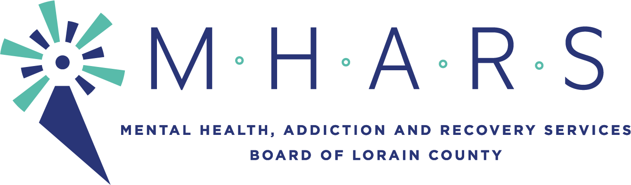
MHARS Finance Committee
Time: Apr 13, 2021 05:00 PM Eastern Time (US and Canada)

The meeting will be seen by the public via Facebook Live:
Facebook.com/mharslc

AGENDA ITEMS

Informational Items:
1. List of Contracts Authorized by the Executive Director on Behalf of the MHARS
Board of Directors

Recommendations:
1. Review and recommendation for approval of the MHARS Board FY21 Financial
Statements through March 2021
2. Review and recommendation for approval of the MHARS Board Listing of Expenses
for March totaling $1,749,069.17
3. Review and recommendation for approval of the MHARS Board FY21 budget
revisions

Discussion of Crisis Receiving Center

Discussion of any other finance related items

Discussion of Consent Agenda items

Next meeting of the Finance Committee will be May 18, 2021 at 5:00pm

