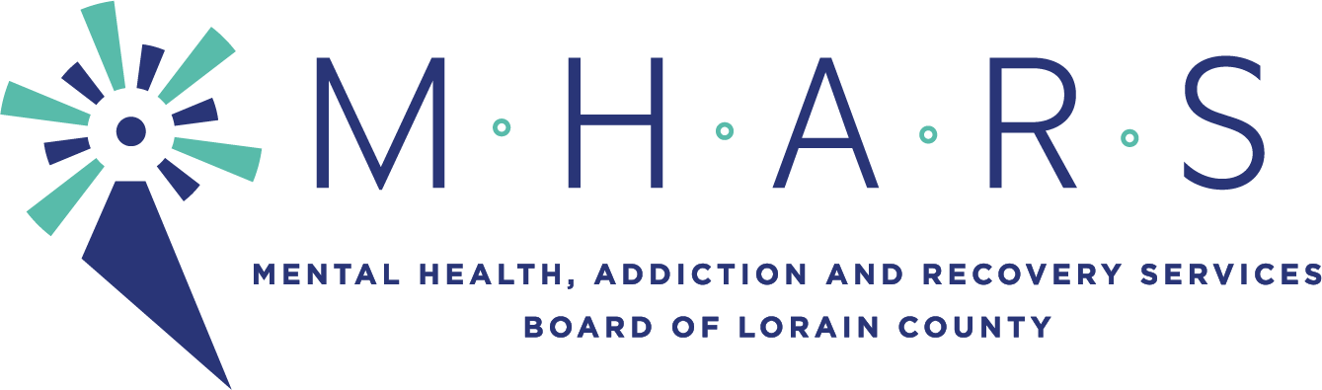

PUBLIC NOTICE
MHARS Community Planning & Oversight Committee
Time: Apr 15, 2021 5:15 PM Eastern Time (US and Canada)

The meeting will be seen by the public via Facebook Live:
Facebook.com/mharslc

Committee members: David Ditullio, Committee Chair, Brandon Bobbitt, Dr. Denise Eacott; Dr. Tracey Frierson, Regan Phillips, Sandra Premura, Dan Urbin, Pamela Waite, Kreig Brusnahan, Hope Moon (ex officio)

Expected Staff: Elaine Georgas, Mark Johnson, Barry Habony, Arielle Edwards, Rebecca Jones, Amanda Divis

Expected Guests:
Mark Clendenin, Regional Business Development Manager, NE, Bureau of Workers’ Comp
Brooke Sherman, Director of Crisis Services, The Nord Center
Don Schiffbauer, CEO, The Nord Center

I. Informational:
A. Provider Presentation – Substance Use Recovery and Workplace Safety Program Attachment A
B. Crisis Continuum Update –The Nord Center Attachment B
II. Recommendations:
A. Treatment Services Allocation Increase
B. Gambling Addiction Treatment Allocation Adjustment –
C. CPST Incentive Adjustment
D. FR CARA Allocation Adjustments
III. Old Business
IV. New Business
V. Determination of Consent Agenda

Following Meeting: May 19, 2021 5:15pm

