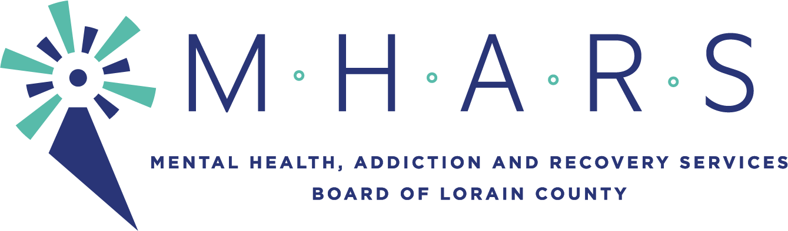
Topic: MHARS Governance Committee meeting
Time: Apr 14, 2021 05:30 PM Eastern Time (US and Canada)

AGENDA
Committee Members: David Ashenurst (Chief Governance officer), David DiTullio, Inez James, Karen McIlwaine, Hope Moon (ex-officio), Daniel Urbin

Expected Staff: Elaine Georgas, Patrice McKinney

- Call to Order

- Continued review of consent agenda process (Attachments 1, 2, 3, 4)

- Conflict of Interest Policies (Attachments 5, 6, 7, 8, 9, and Exhibit A)

- (New Standing Agenda Item): New Business
- Status of CLAS training as Board Members’ educational training this fiscal year

- Determine Consent Agenda items

- Determine Next Meeting Date and Time

