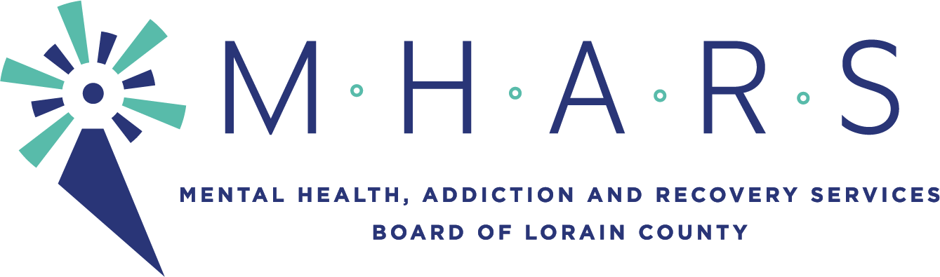
MHARS Finance Committee
Time: May 18, 2021 05:00 PM Eastern Time (US and Canada)

The meeting will be seen by the public via Facebook Live:
Facebook.com/mharslc

AGENDA ITEMS
Informational Item:
1. List of Contracts Authorized by the Executive Director on Behalf of the MHARS
Board of Directors (p. 2)
Recommendations:
1. Review and recommendation for approval of the MHARS Board FY21 Financial
Statements through April 2021. (p. 3-11)
2. Review and recommendation for approval of the MHARS Board Listing of Expenses
for April totaling $1,438,417.03. (p. 12-15)
Informational Item:
2. Review of 5 Year Budget Forecast (p. 16-19)
Recommendations:
1. Review and recommendation for approval of the Integrated Services Partnership
FY22 Budget for which the MHARS Board is the fiscal agent. (p. 20)
2. Review and recommendation for approval of the MHARS Board FY22 Budget. (p.
21-35)
3. Review and recommendation for approval of the MHARS Board County Tax Budget
for Calendar Year 2022. (p. 36-47)
4. Review and recommendation for approval of the MHARS Board commitment to the
Lorain County Crisis Response Project for the Crisis Stabilization Center. (p. 48-50)

Discussion of any other finance related items.

Discussion of Consent Agenda items.

Next meeting of the Finance Committee will be June 15th 2021 at 5:00pm.

