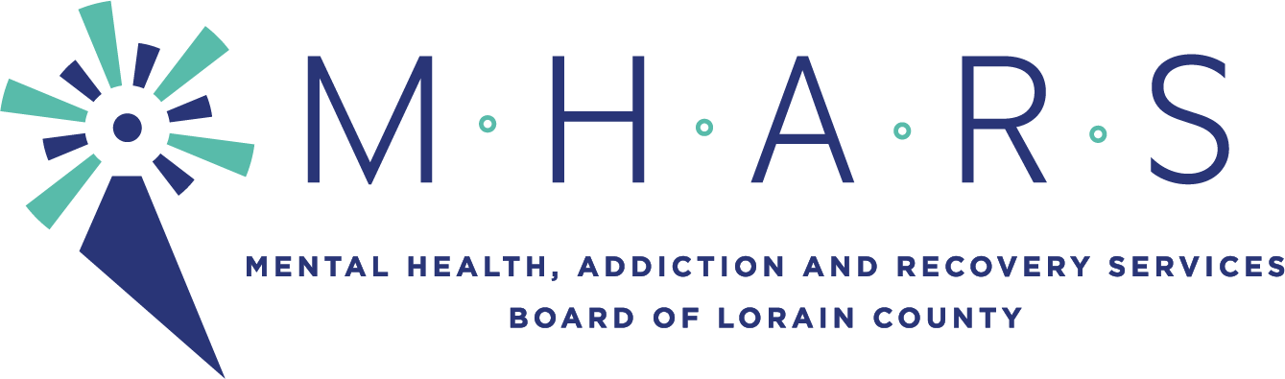

PUBLIC NOTICE
MHARS Community Planning & Oversight Committee
Time: May 19, 2021 5:15 PM Eastern Time (US and Canada)

The meeting will be seen by the public via Facebook Live:
Facebook.com/mharslc

I. Informational:

A. Crisis Continuum Update –Peg’s Foundation

II. Recommendations:

A. Network Agency Budget Recommendations FY22

III. Old Business

- Proposal to Governance to allow consent agendas for committee meetings

IV. New Business

V. Determination of Consent Agenda

Following Meeting: June 16, 2021 5:15pm

