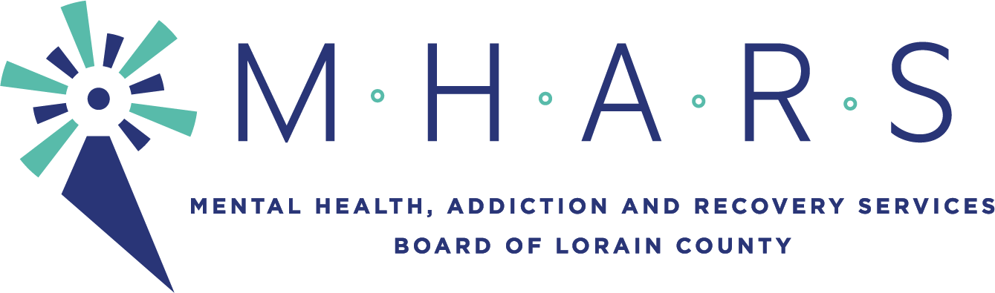

PUBLIC NOTICE

Topic: MHARS Special Membership Committee meeting

Time: May 24, 2021 05:45 PM Eastern Time (US and Canada)

The public is welcome to view the meeting via Facebook Live on the MHARS Board’s website.

Committee Members: Tim Carrion (Committee Chair), Regan Phillips, Karen McIlwaine,
Sandra Premura, Karen Sutera, Kreig Brusnahan, Dr. Hope Moon (ex-officio)

Board Member: David Ashenhurst

Staff: Patrice McKinney and Elaine Georgas

