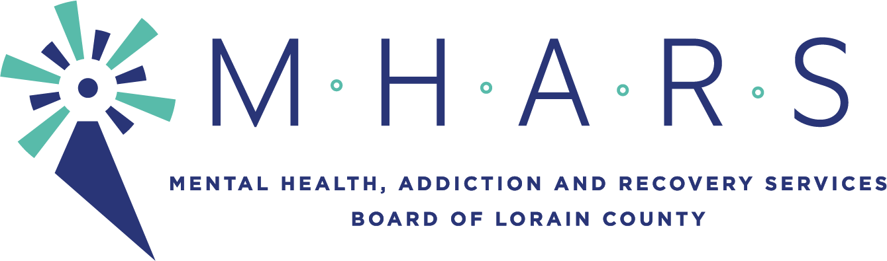
MHARS Finance Committee
Time: June 15, 2021 05:00 PM Eastern Time (US and Canada)

The meeting will be seen by the public via Facebook Live:
Facebook.com/mharslc

AGENDA ITEMS

I. Recommendations:
1. Review and recommendation for approval of the MHARS Board FY21 Financial
Statements through May 2021. (p. 2-10)

2. Review and recommendation for approval of the MHARS Board Listing of Expenses
for May totaling $1,761,775.38. (p. 11-14)

3. Review and recommendation for approval of the MHARS Board FY21 budget
revisions. (p. 15-16)

4. Review and recommendation for approval of the MHARS Board FY22 budget
revisions. (p. 17)

II. Discussion of any other finance related items.

III. Discussion of Consent Agenda items.

Next meeting of the Finance Committee will be in person July 13th or August 17th 2021 at
5:00pm.

