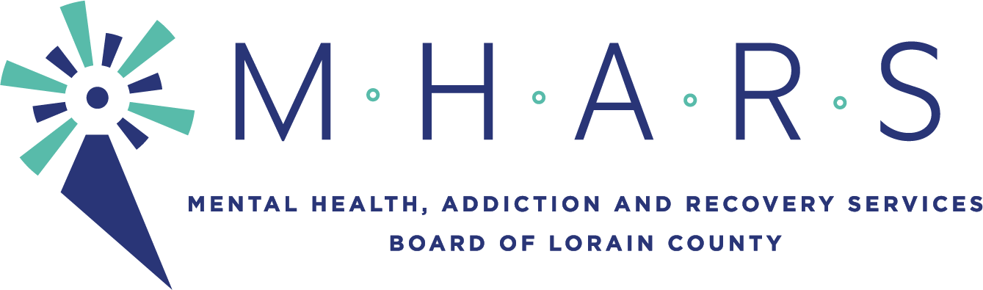
PUBLIC NOTICE

Topic: MHARS Governance Committee meeting
Time: June 9, 2021, 05:30 PM Eastern Time (US and Canada)

AGENDA

Committee Members: David Ashenurst (Chief Governance officer), Monica Bauer, David DiTullio, Inez James, Karen McIlwaine, Hope Moon (ex-officio), Daniel Urbin

Expected Staff: Michael Doud, Elaine Georgas, Patrice McKinney

  - OhioMHAS Application page correction

  - Conflict of interest Statement (Will be emailed on Monday)

  - Use of consent agendas in committee meetings (Members: Any research to share at this meeting would be appreciated).

  - Abstentions when voting

  - Bylaws Article VIII, Section 1: Membership Committee – Slate of Officers process

  - New business
    - Clean-up of Bylaws
    - Other new business

  - Determine consent agenda items

  - Next meeting: To be determined.

