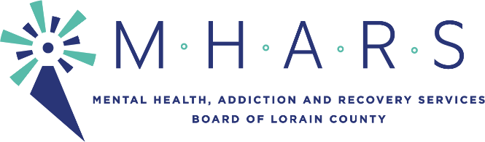
Membership Committee Meeting
Tuesday, August 3, 2021, 6:00 p.m.
Amy Levin Center, 1165 North Ridge Rd. East
Lorain, OH 44055

REVISED AGENDA

Committee Members: Kreig Brusnahan (Committee Chair), Mike Babet, Tim Carrion, Inez James, Sandra Premura, Daniel Urbin (ex-officio)

Staff: Michael Doud, Patrice McKinney

- Logistics prior to interviews (see sample interview questions)
- Interviews:
  - 6:15 p.m. Mark Skellinger (application and resume pending)
  - 6:45 p.m. Mary Siwierka (see attached application and resume)
- Next steps regarding:
  - One (1) OhioMHAS addiction family member vacancy (B. Bobbitt) through 06/30/2025 (see Dr. Hope Moon’s application and resume)
  - Raquel Gettis interviewed 02/11/2021 (see attached application and resume)
  - One (1) OhioMHAS partial-term vacancy through 06/30/2023-(Loretta Jones’ application to be sent to OhioMHAS)
  - Two (2) Commissioner vacancies through 06/30/2025
- New business: A recent application withdrawn
- Review Board Member attendance (see attached)
- Mentor for Mike Babet
- Determine consent agenda items
- Next meeting: To be determined
- Adjourn

