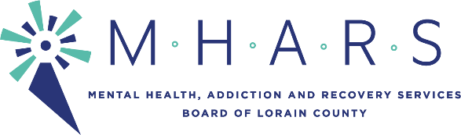

PUBLIC NOTICE

TO: All Board Members

FROM: Board Chair Daniel Urbin

SUBJECT: SPECIAL Board Meeting

DATE: Tuesday, September 7, 2021

CC: See distribution list below.
______________________________________________________________________________

There will be a SPECIAL Board meeting of the Mental Health, Addiction and Recovery Services (MHARS) Board of Lorain County on:

DATE: Thursday, September 9, 2021

TIME: 5:00 p.m.

PLACE: Amy H. Levin Conference and Learning Center
1165 North Ridge Rd. East, Lorain, Ohio

Distribution:
Lorain County Commissioners
Legislators
Local Mayors
Director, Ohio Department of Mental Health and Addiction Services
The Chronicle-Telegram
The Morning Journal
The Plain Dealer
Providers
WEOL
WOBL/WDLW
WNZN
MHARS Staff

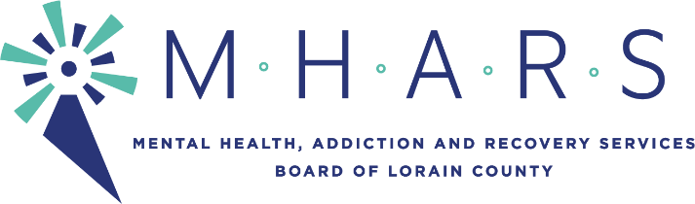
Special Board Meeting Agenda
September 9, 2021, 5:00 p.m.

- Call to order by Chair Daniel Urbin

- Oath of Office of new Board Members Dr. Hope Moon and Mark Skellenger by Regan Phillips

- Roll call by Patrice McKinney

- Membership Committee Report by Kreig Brusnahan (Handout at meeting)

- Rebranding by Daniel Urbin

- Levy by Nancy Kelsey

- Crisis Service Receiving Center by Michael Doud (Handout at meeting)

- Executive Director Job Description and Evaluation by Daniel Urbin

- Unfinished business

- New business

- Public comment (Please limit comments to no more than three minutes. Thank you).

- Adjournment

