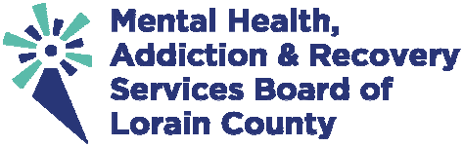

PHOTO/STORY RELEASE AND AUTHORIZATION FORM
I hereby grant permission to the Mental Health, Addiction and Recovery Services (MHARS) Board of Lorain County and/or media agencies to use my name, likeness, image, photograph, interview or story in official MHARS Board of Lorain County/levy campaign or affiliated printed publications, multi-media presentations, advertisements, website, social media, or other media/products without further consideration. I acknowledge MHARS Board of Lorain County’s right to crop or treat photographs at its discretion. This authorization includes, but is not limited to, the right to edit or duplicate and to use or reuse my name, likeness, image and/or story in whole or in part.

I acknowledge that I have no interest or ownership in the publications in whole or part. I also authorize the right to broadcast, exhibit, market, sell and otherwise distribute the publications, products or programs, either in whole or in part, and either alone or with other products.

In consideration of all of the above, I hereby acknowledge receipt of reasonable and fair consideration. I also agree to indemnify and hold harmless from any claims the following:
- All Board Members of the MHARS Board of Lorain County
- All Employees of the MHARS Board of Lorain County
- All MHARS Board of Lorain County affiliates, partners, and provider agencies
- Lorain County

I have read the above Release and Authorization and understand its content and agree to be bound by its terms. Name (s) (please print):
Date: E-mail:

Address:
Phone:

Signature:

PLEASE FILL OUT THE INFORMATION BELOW IF THE PERSON IS UNDER 18 years of age
(siblings and minor family members can be listed on the same sheet):
Child name(s) (please print): Child birthday(s): Adult family members’ names (please print): Signature of parent/guardian:

