MHARS Board Mini-Provider Directory

Our Mission:
We invest in mental health, addiction and recovery services to build a healthier community.

Our Vision:
Prevention, treatment and recovery are essential to a healthier, more connected Lorain County - where every individual and family is empowered to thrive.

Our goal is to maximize delivery of these health services. It means providing the right care, in the right setting, at the right time.

Our Core Values:
Person-Centered: We honor individual choice and place clients and families at the center of everything we do.
Collaboration: We believe in the power of partnerships to strengthen our collective impact.
Compassion and Respect: We lead with empathy, reduce stigma and advocate for those in need.
Excellence and Accountability: We commit to high quality, evidence-based practices and working with integrity.
Innovation: We are solution-focused and embrace bold
thinking to solve challenges.
Accessibility: We remove barriers and expand capacity so everyone can access services and support.

Suicide & Crisis Hotline: 988 Crisis Text Line: 4hope to 741741 Addiction Helpline: 440-989-4900
Domestic Violence: 1-866-213-1188
MHARSLC.ORG
440-233-2020

1173 North Ridge Road E, Ste. 101, Lorain, OH 44055
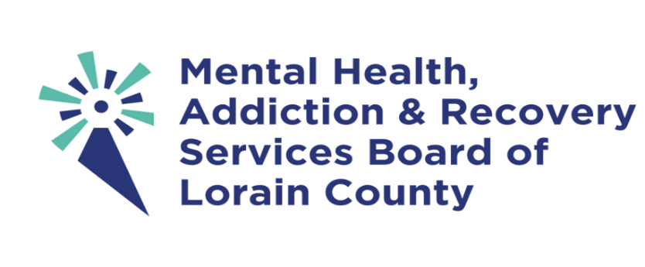
Q U I C K D I R E C T O R Y O F M H A R S M E N T A L H E A L T H , A D D I C T I O N A N D P R E V E N T I O N P R O V I D E R S :
A p p l e w o o d C e n t e r s , I n c . , 4 4 0 - 3 2 4 - 1 3 0 0 a p p l e w o o d c e n t e r s . o r g
Beech Brook, 216 - 831 - 2255 , beechbrook. org
Bellefaire JCB, 800 - 879 - 2522 bellefairejcb. org
Big Brothers Big Sisters, 440 - 277 - 6541 bigloraincounty. org
Catholic Charities Lorain County, 440 - 366 - 1106 , ccdocle. org
El Centro ( Navigator), 440 - 240 - 7025 lorainelcentro. com
Far West Center, 440 - 988 - 4900 farwestcenter. com
Gathering Hope House, 440 - 233 - 7400 gatheringhopehouse. com
Let’ s Get Real, Inc., 440 - 963 - 7042 letsgetrealinc. org
LMM Guardianship Svcs, 216 - 696 - 1132 lutheranmetro. org
Lorain UMADAOP, 440 - 246 - 4616
lorainumadaop. com
NAMI Lorain County, 440 - 240 - 8477 nami- lc. org
Neighborhood Alliance, 440 - 233 - 8768 myneighborhoodalliance. org
New Sunrise Properties, 440 - 365 - 9600 newsunriseproperties. org
Riveon ( Addiction/Substance Use Assessment),
440 - 989 - 4900 Option 2
riveonhealth. org
Riveon ( Main Number), 440 - 233 - 7232 riveonhealth. org
Ohio Guidestone, 440 - 260 - 6101 ohioguidestone. org
Pathways Counseling and Growth, 440 - 323 - 5707 , pathwayscounselingcenter. com
Primary Purpose, 440 - 219 - 4774 primarypurposecenter. com
Psych and Psych Services 440 - 323 - 5121 psychandpsych. com
Road to Hope House, 440 - 309 - 4284 road- to- hope. org
Safe Harbor/Genesis House, 440 - 323 - 3400 genesishouseshelter. org
Signature Health, Inc, 440 - 578 - 8200 signaturehealthinc. org
Silver Maple Recovery, 855 - 200 - 7521 silvermaplerecovery. com
Stella Maris, Inc., 216 - 781 - 0550 stellamariscleveland. com

